Do it
Put the towers in height order from the shortest to the tallest.
Tallest

A B C Shortest

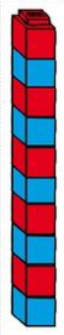


Put the boxes in height order from the shortest to the tallest.
Tallest

Shortest

A B C

A B C





Put the lines in height order from the shortest to the tallest.

Tallest

A B C Shortest

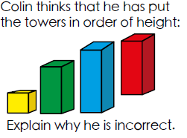
Secure it
Co Colin is incorrect because I know that ___ is the whole and
Key words
shorter
taller
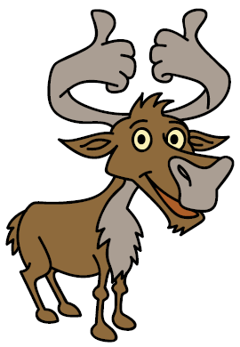
.

Explain why he is incorrect.

Explain why he is incorrect.
Colin is incorrect because Colin measured the towers from a different starting point so the red tower is not _________________ than the blue tower and the red tower is __________________ than the blue tower.

Deepen it (Challenge):
Read below and put Colin, Coco, Mrs. Michienzi and Miss Newell in order of height.
Colin is taller than Coco. Miss Newell is shorter than Mrs. Michienzi. Miss Newell is taller than Colin.





Colin Coco Mrs. Michienzi Miss Newell

