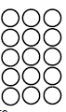
Do it
Can you measure the height of objects in your house with your finger step?
List them in the table below
Book | 4 finger steps

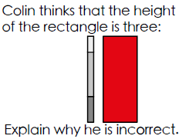
Secure it
Key words
equal

Co Colin is incorrect because I know that ___ is the whole and


Colin is incorrect because I know that when I measure height I need to use a unit that is of _______ size.

Deepen it:
 Height Hunt

Find an object that is 7 units of your choice in your in height.
Find an object that is a total of 10 units of choice tall.
Find two objects that have a total height of 20 units of your choice.
Units of choice suggestions:
Cubes
Pencils
Paper clips
Lego
Toilet rolls
Dominoes

