Touch counting
Look at the hundred square below. Can you show your adults any patterns that you notice?
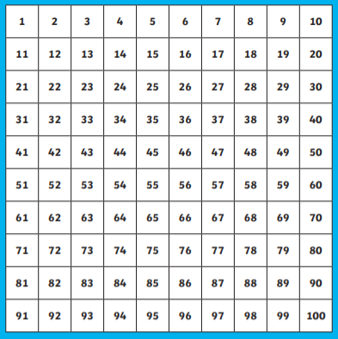
Remember
When I count forwards, the numbers get larger.
Remember
When I count backwards, the numbers get smaller.
With your child, please could you help them practise counting to and from the numbers below, independently? They can use the hundred square to help them. Encourage them to follow with their finger as they count. This practise could be done for a few minutes daily to support their maths learning.
Forwards | Backwards
Start from 55 and finish at 61 | Start from 70 and finish at 60
Start from 81 and finish at 100 | Start from 95 and finish at 85
Start from 11 and finish at 21 | Start from 22 and finish at 10

Counting forwards to 100
Watch this video. Are children able to count along with the video? Children can practise counting along with the song: https://www.youtube.com/watch?v=bGetqbqDVaA
Counting backwards from 100
Watch this video. Are children able to count along with the video? Children can practise counting along with the song: https://www.youtube.com/watch?v=ucRuGbjurGY

Look at the sequences below. Use your 100 square to help you complete them:

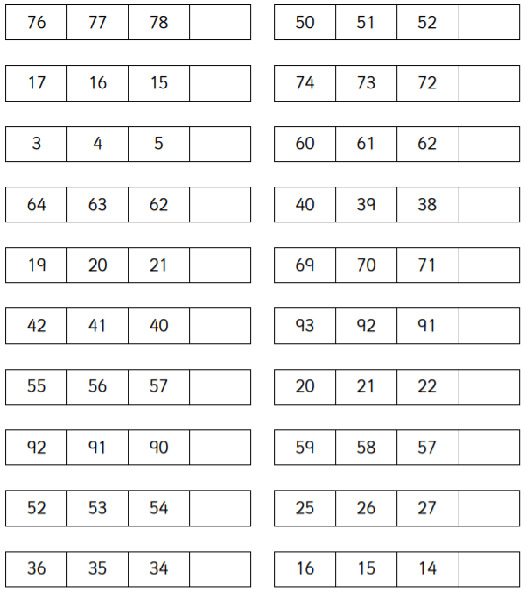
Think about it
Are the sequences counting forwards or backwards?

