Do it
Complete the part-part-whole models:
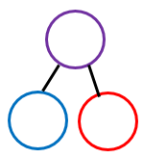  13  17 | 12  14  17  17
10  Colin thinks that he has partitioned 17.  3434  44  34  44  54  17 | Key words  8 17 9  Repeating  17  9
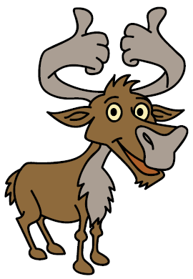
Secure it

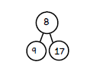
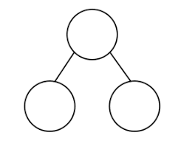
Show the correct partitioning on the part part whole model.

Explain why he is incorrect.
Colin is incorrect because I know that ___ is the whole and ____ and ____ are parts.

Show it
Can you represent all part-part whole models.
Deepen it


