
Do it
Calculate and represent:

10 + = 17


11 + = 17

17 = 3 +

17 = + 4

Show me
Can you represent and write number sentences for the other addition facts for 17?


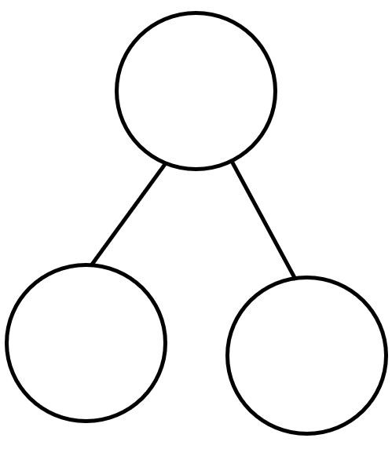
Key words
7
1
17

Secure it
Co Colin is incorrect because I know that ___ is the whole and
Coco thinks that 1 and 7 make 17.

Explain why she is incorrect.
Colin is incorrect because I know that _______is the whole and _______ and _______ equal _______.
The correct calculation is:
or
Deepen it:
Find the missing numbers. Solve it in different ways. Can you solve it using only 2 numbers?


