Do it
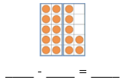
17 – 6 = ___

___ = 17 - 4

17 – 8 = ___

17 – 7 = ___

___ = 17 – ___

___ = 17 – 3

Show me
Can you find and represent all of the other subtraction facts for 17

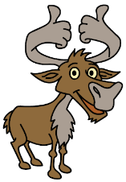
Secure it
Colin thinks 10 = 7 - 17
3434
44
34
44
54

Key words
10
17
7

Explain why he is incorrect.

Correct number sentence: ________________________________________________________

Colin is incorrect because you always take away from the whole so _____ is the whole, _____ is the part that should be taken away and _____ is the part that I have left.

Deepen it - Draw a picture to represent each problem and solve it:
- A plant has 17 leaves. 3 fall off. How many are left?
- There are 17 bikes in a park. 5 go away. How many are left?
- There are 17 buns on a plate. Colin eats 8. How many buns are left?
Can you make up any more stories about 18?

