3D Shapes
Watch the video below – this can help you to remember the names of the 3D shapes:
https://www.youtube.com/watch?v=guNdJ5MtX1A


Can you tell your parents at home about the shapes
Remember:
A 3D shape is a solid shape.
below? What do you notice about them?
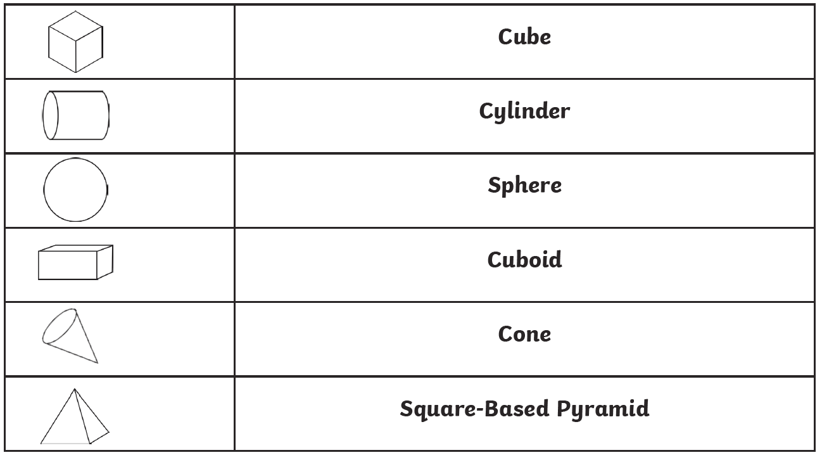
Can you name the 3D shapes before. Use the key words to help you.
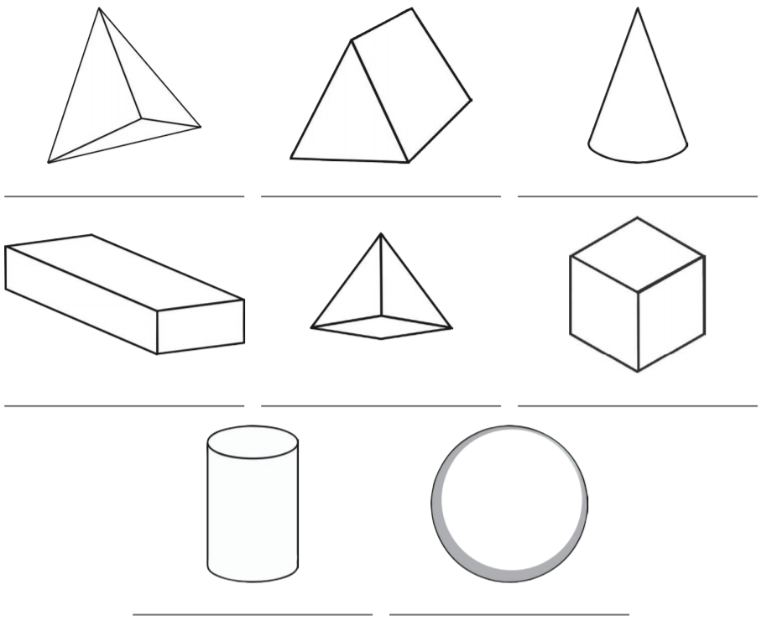
Key words
Sphere
Cube
Cone
Pyramid
Cylinder
Triangular prism
Tetrahedron
Cuboid

Challenge: Do you notice any of these shapes in your home? Eg. A football is a sphere.
Answers



