Do it
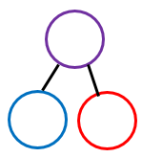  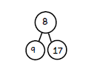  Complete the part- part whole models:  18  10 | 11  18  14  18
Coco thinks that he has partitioned 18.  3434  44  34  44  54  3  18 | Key words  8 18 10  Repeating  18  9
Secure it

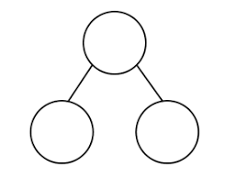
18
8
1
Show the correct partitioning on the part part whole model.

Explain why she is incorrect.
Coco is incorrect because I know that ___ is the whole and ____ and ____ are parts. The 1 should be ____________.

Show it
Can you represent all part-part whole models.
Deepen it



