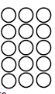
Do it
Calculate and represent:

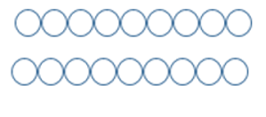
10 + = 18


13 + = 18

18 = 3 +

18 = + 6

Show me
Can you represent and write number sentences for the other addition facts for 18?


Secure it
Co Colin is incorrect because I know that ___ is the whole and
Coco thinks that 12 = 6 + 18.

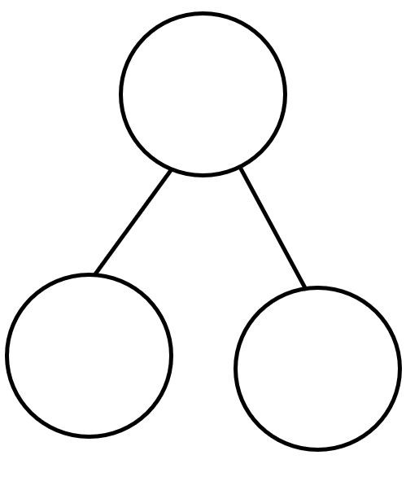
Key words
12
6
18

Explain why she is incorrect.
Coco is incorrect because I know that _______is the whole and _______ and _______ equal _______.
The correct calculation is:
or

Deepen it:
Colin grows 18 flowers. They are either pink or yellow. There are more pink than yellow flowers. How many of each colour could he have?

Coco grows 18 flowers. They are red, purple or orange. There are more red than purple and more purple than orange flowers. How many of each colour could she have?

