Do it
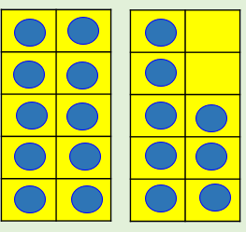
18 – 8 = ___

___ = 18 - 10

18 – 6 = ___

18 – 7 = ___

___ = 18 – ___

___ = 18 – ___

___ = 18 – 9

Find more
Can you find and represent all of the other subtraction facts for 18
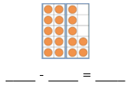

Secure it
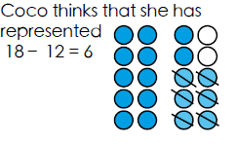 3434
44
34
44
54

Key words
18
12
6
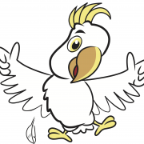

Explain why she is incorrect.
Correct representation

Coco is incorrect because I know that _______ is the part that I am taking away from ______ and _______ is the part that I have left.






Deepen it -



