Do it
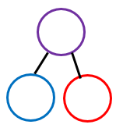  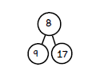  Complete the part- part whole models:  19  4 | 9  19  18  19
Coco thinks that he has partitioned 19.  3434  44  34  44  54  7  19 | 5  Key words  8 19 11  Repeating  19
Secure it

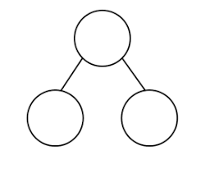
8
19
11

Show the correct partitioning on the part part whole model.

Explain why she is incorrect.
Coco is incorrect because I know that ___ is the whole and ____ and ____ are parts.

Show it
Can you represent all part-part whole models.
Deepen it



