
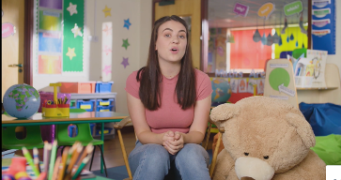
Challenge:
Can you think of some rules that you need to follow to be safe online?

_____________________________________________________________________

