Maths
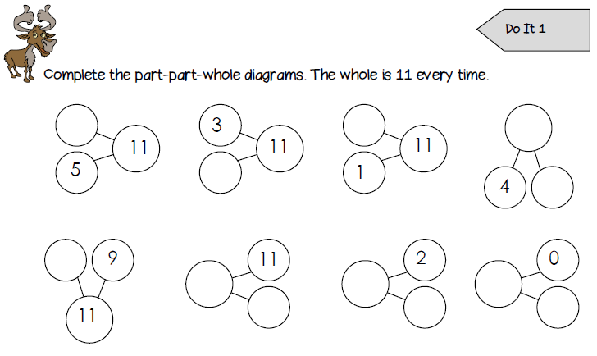
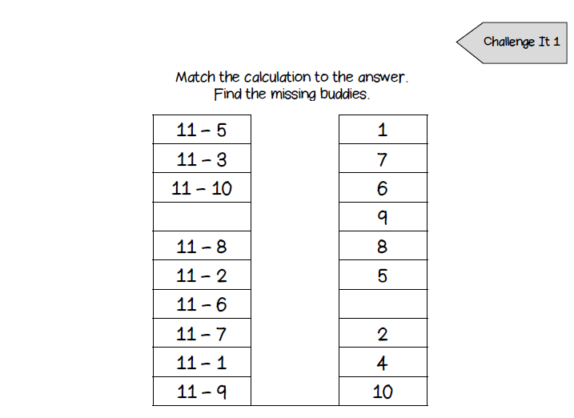
Can you watch the video to practising counting in tens to 100? - https://www.youtube.com/watch?v=7stosHbZZZg
Phonics
Can you circle the correct spellings of the words below? Use the pictures to help you.
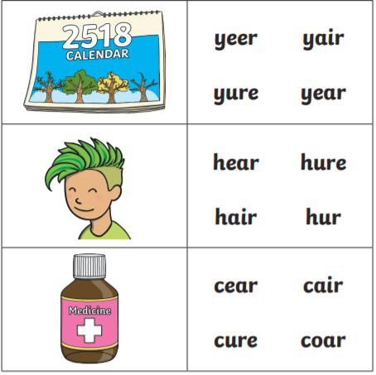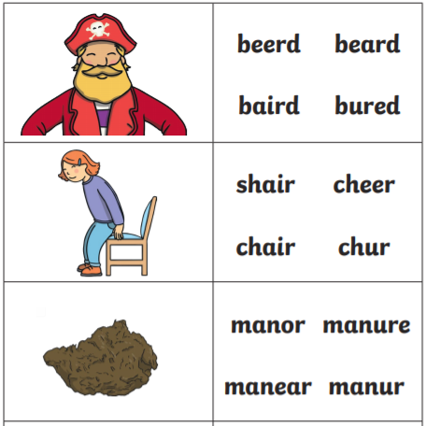
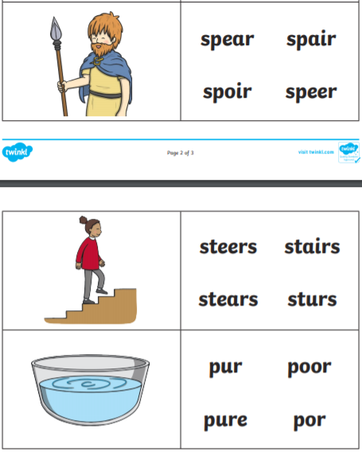
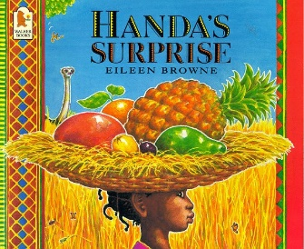
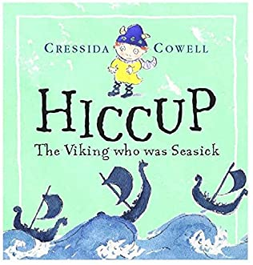
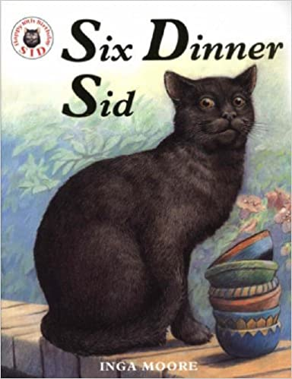
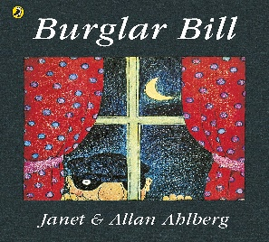
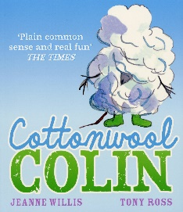
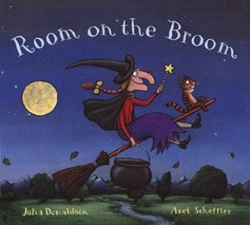

English
Think about the books we have read so far this year. Who is you r favourite author? Think about what questions you would ask if you could meet them.

Favourite author: _________________________________________________________

Questions to ask my favourite author: _________________________________________

Please look at World Book Day activities for some more fun ideas!

