==.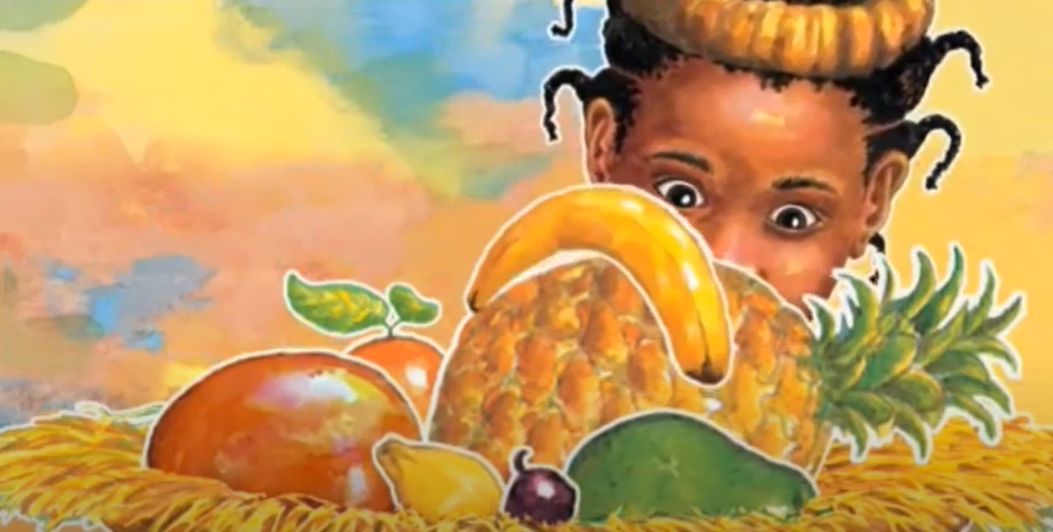  One day | 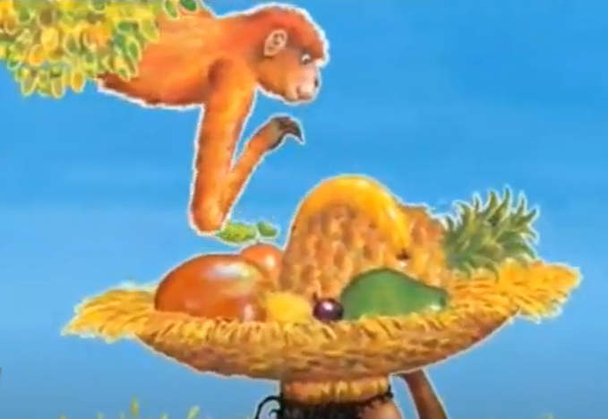  Then | 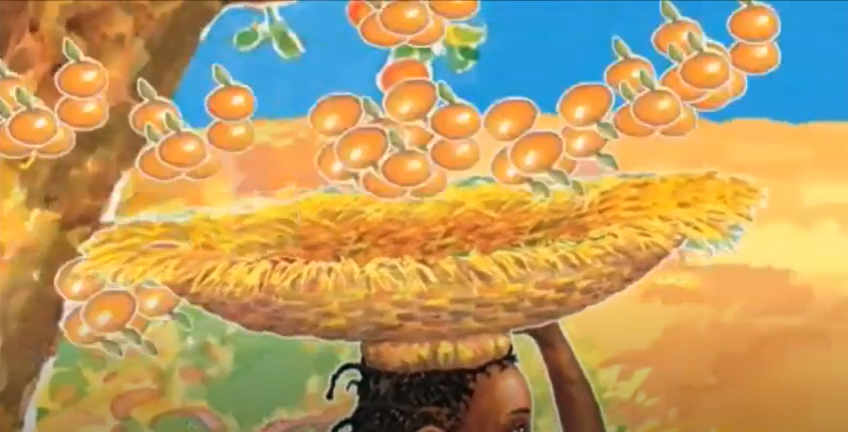  After that |   At last

Handa’s surprise online:
https://www.youtube.com/watch?app=desktop&v=AJdPlMebjAw

