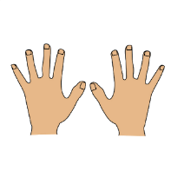
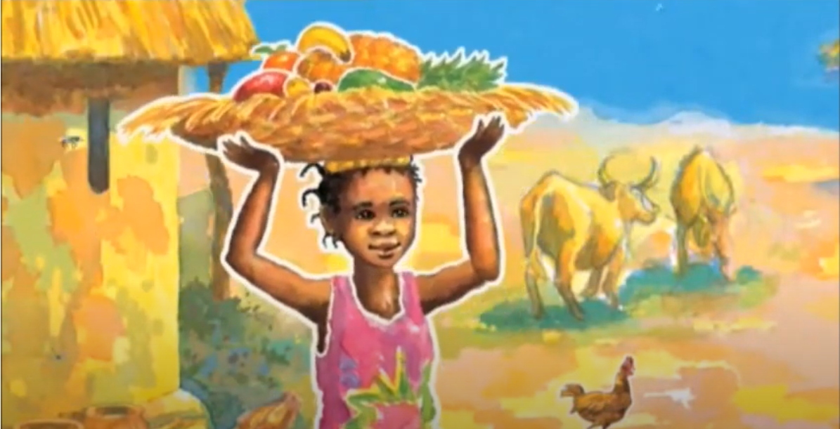
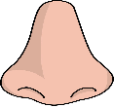
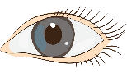


Handa put seven fruits in a basket for her friend Akeyo. On her way, Handa noticed lots of things.
Remember!
Start your sentences with:
She can hear…
She can smell…
She can feel…
She can see…

