
Look at the sentences below. Do they need a question mark or a full stop at the end? Put the correct answer in the box.
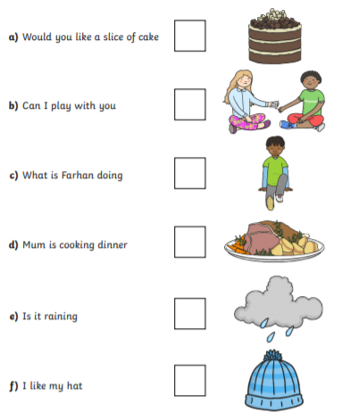
Can you write down three sentences that you ask your adults at home? Remember to add in your question marks!

Challenge
Can you think of three questions to ask about the below picture?


