Can you finish editing Miss Amies and Mrs. Kitchen’s non-chronological report using the checklist?
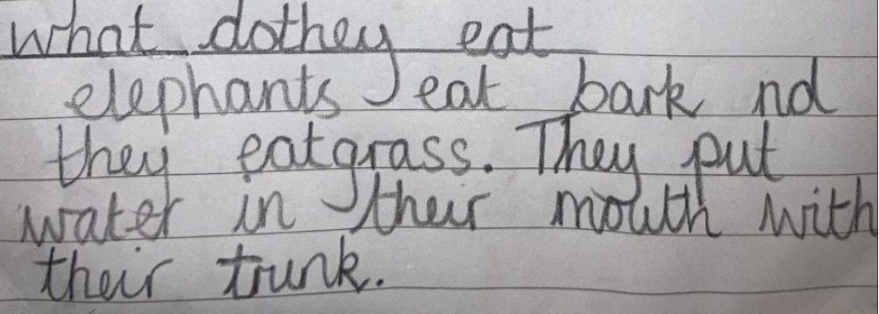
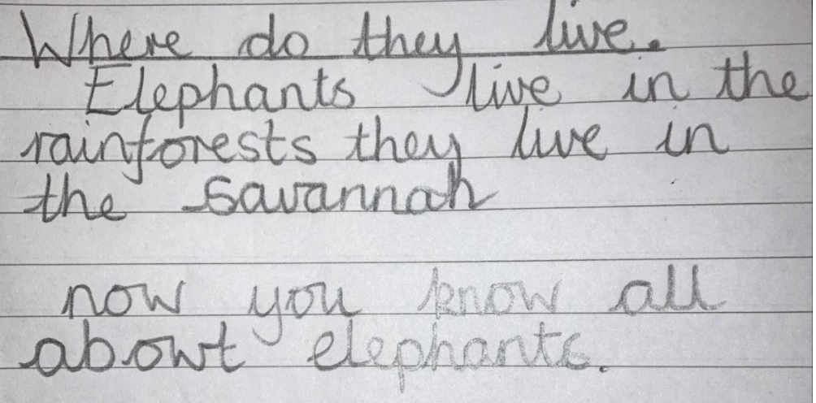
Challenge:
Can you use the checklist to check your own non-chronological report about giraffes?


