Can you put capitals letters in all of the proper nouns?
I have a dog and his name is oreo.

fred and lana went to play in the park and they saw philip.

On sunday we will go to the beach with jill.

jen’s birthday is in september.

The mum was waiting for handa to eat dinner.
Can you use the pictures to help you write a sentence, remembering capital letters for proper nouns?
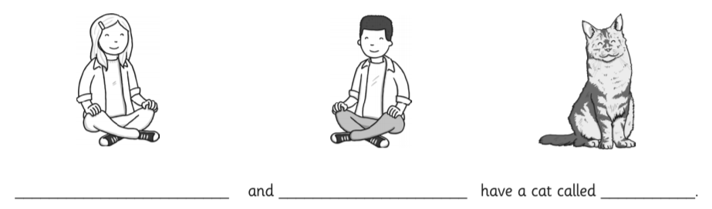
Challenge
Can you write your own sentences using proper nouns?



