Can you design your favourite healthy meal?
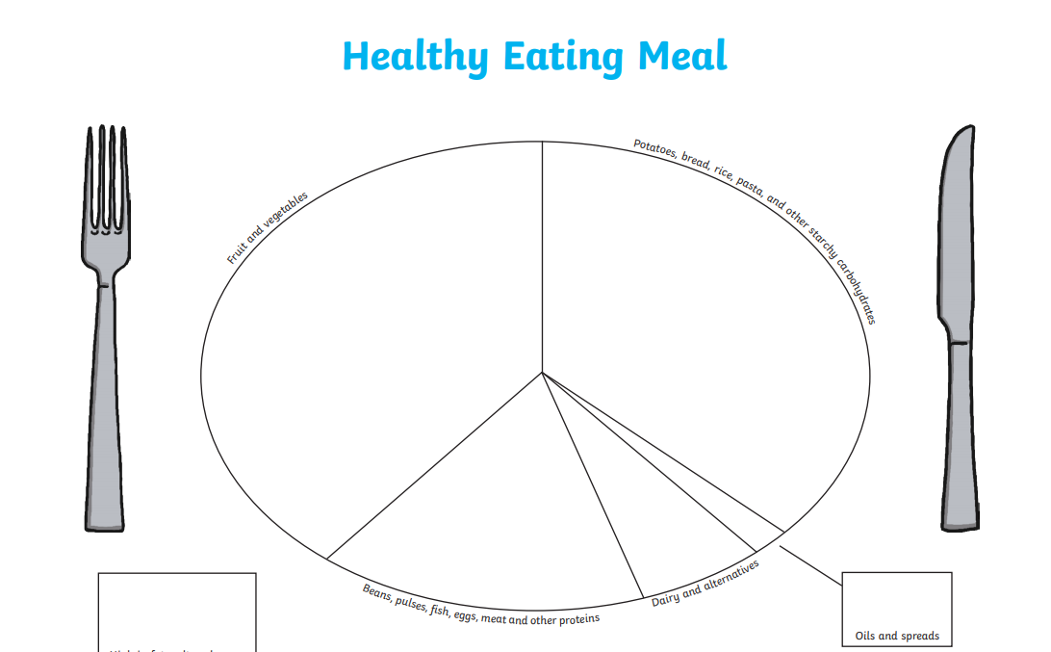

Challenge
Can you write why this is your favourite meal?

____________________________________________________________________________________________________________________________________________

____________________________________________________________________________________________________________________________________________

____________________________________________________________________________________________________________________________________________

