Question marks
This is a very strange picture! Write a list of all of the questions that this picture makes you think of.
Challenge:
Can you ask your questions to your adults and see if they can answer them?
Make sure you remember your question marks and question words!
Example: How small are these people?
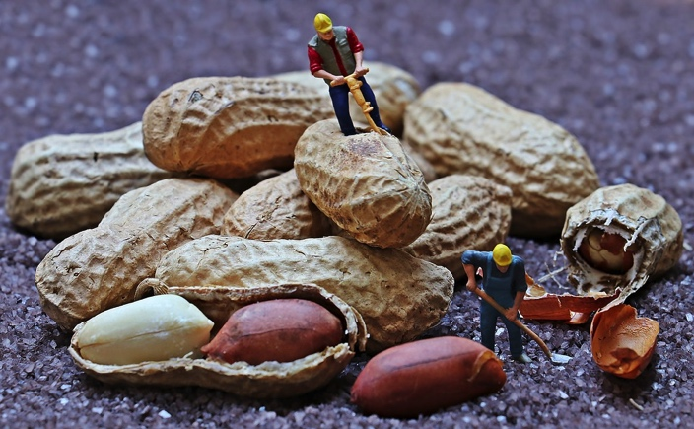



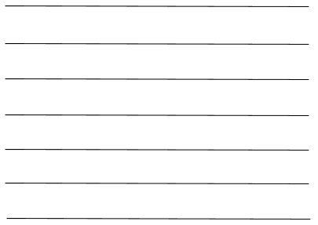
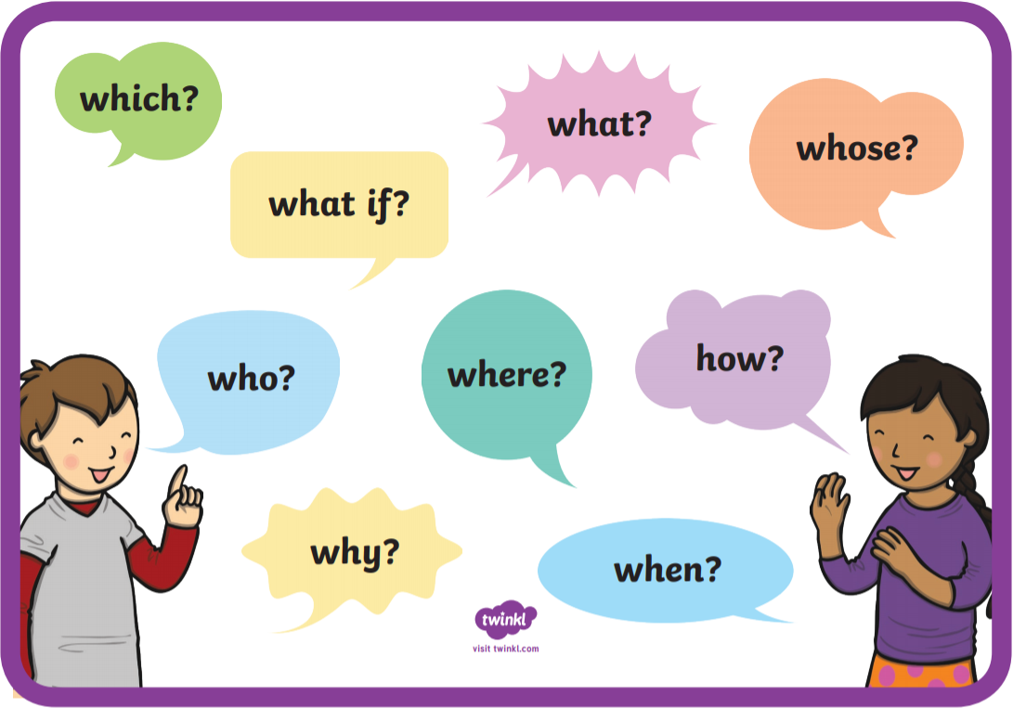
Challenge:
Can you think of a question for each of the question words?

Capital letters and full stops
Can you be the teacher and correct the capital letters and full stops below?
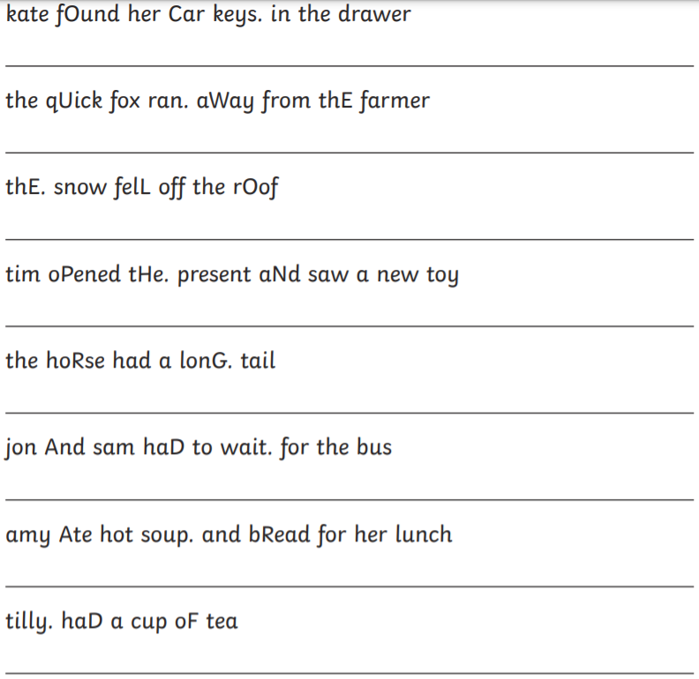
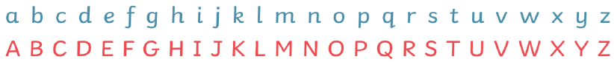
Remember:
Full stops come at the end of a sentence.
Capital letters are used at the start of a sentence and for names of people, pets, places, days of the week and months (proper nouns).

Using the conjunction ‘and’ in writing.

Conjunctions ‘and’
Can you join these sentences together using ‘and’? Write the sentence below.

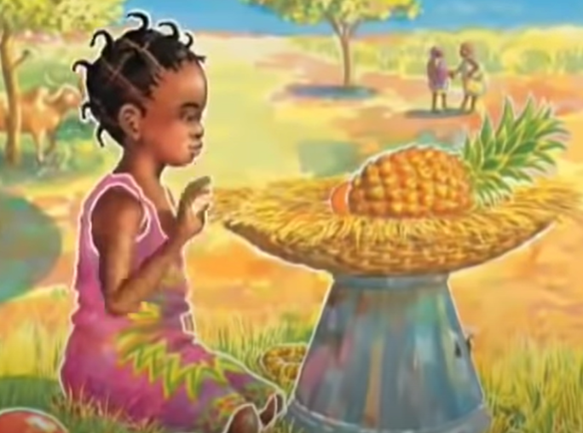
Handa had a basket.
She put lovely fruit in it.

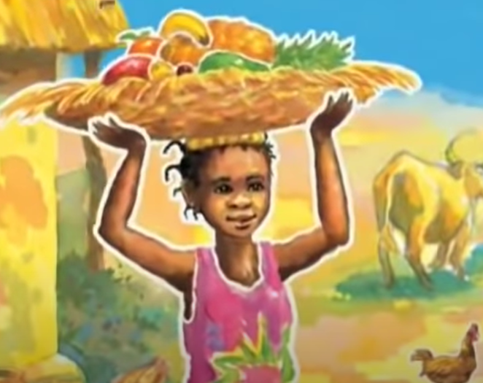
The basket felt heavy in her hands.
The sun was very hot.


Handa had a surprise when she saw the tangerines.
Akeyo laughed lots and lots.

Challenge
Can you invent some sentences of your own using the conjunction ‘and’?

