Friday 26th February 2021
I can use a question mark and question words correctly to write a question sentence about the Gruffalo story.

______________________________________________________________________________________________________________________________________

______________________________________________________________________________________________________________________________________

_____________________________________________________________________________________________________________________________________

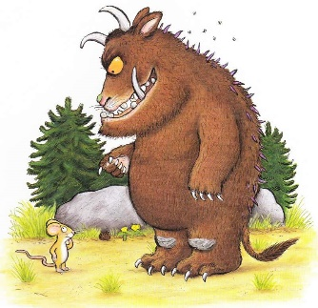
___________________________________________________________________________________________

If you met the Gruffalo what would you like to ask him?

________________________________________________________________________________________________

