Listen to the story of the Gruffalo on Youtube or read by Mrs. Kitchen. Can you look at the sentence openers and finish the sentences using some ideas from the story?
https://www.youtube.com/watch?app=desktop&v=s8sUPpPc8Ws
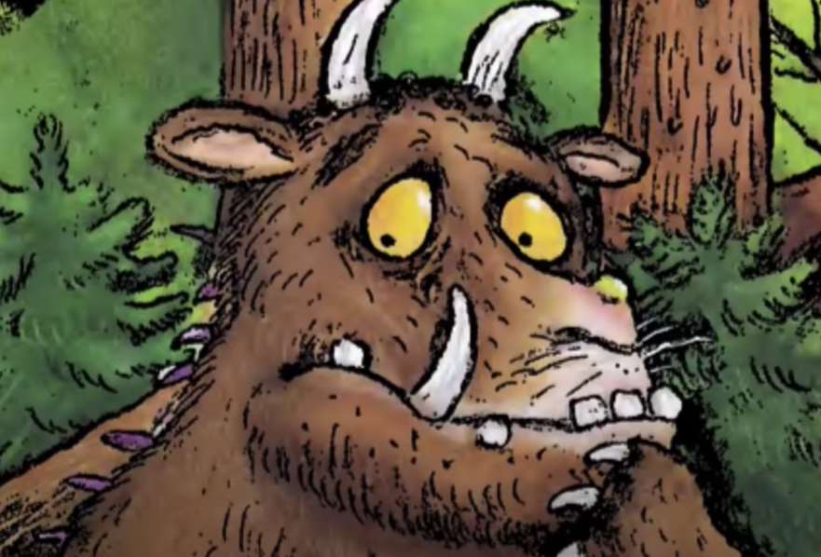

Early one morning

Later on

Then

At last
- Challenge: Can you write some more sentences using the sentence openers below?


