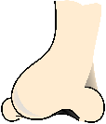
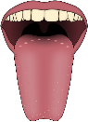

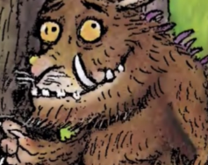

Remember
Begin your sentences with phrases such as:
He has…
He feels like…
He smells like…
Use your senses to help you think of some brilliant descriptive adjectives.
The Gruffalo is
The Gruffalo

