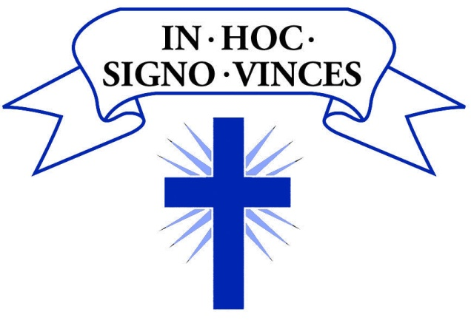

Holy Rood Catholic
Primary School, Swindon.
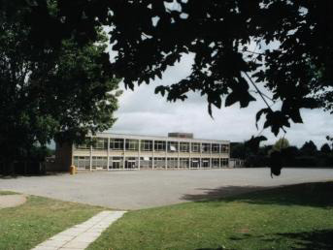
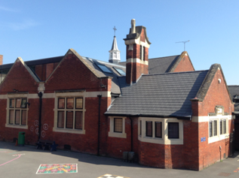

Science Policy

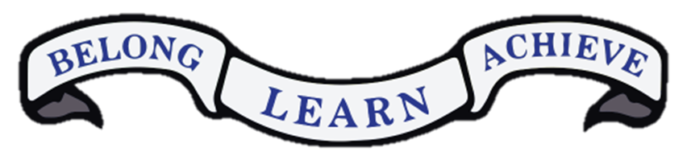

School Vision:

Belong
At Holy Rood Catholic Primary School we will provide a nurturing and inclusive environment enthused by the Spirit of Christ to enable everyone to make a positive contribution, both to the school and the wider community. We will show love, compassion and respect for others.
A sense of unity will be created by forming relationships that are based on trust, loyalty, forgiveness and acceptance; we will endeavour to act justly and be peacemakers as Christ’s disciples, inspired by the Gospel values.
We will encourage a sense of responsibility and help children learn to appreciate God’s world around them through reflection, mission, prayer, healing and peace.

Learn
We resolve to develop a sense of awe and wonder at God’s creation for our children - where creativity flourishes and everyone is inspired to learn, demonstrating a curiosity about the world around them.
We will strive to ensure that all of our learners are able to face new challenges with confidence, in a Christian learning environment where informed risk taking and a resilient attitude are welcomed, encouraged and achieved.
Our positive and enthusiastic approach to teaching and learning will motivate every person. Each will know that they are uniquely loved by God. We will continue to enjoy our learning and reflect on our efforts and achievements, inspiring us to always try our best.

Achieve
The children will be determined in their daily challenges, gaining confidence in their own ability, imagining what they could achieve with continued effort and commitment and working to fulfil the exclusive plan God has for each of them.
By fully engaging in all aspects of school, children will go on to accomplish as ambitious and competent individuals, always striving to achieve their full potential and positively participating in God’s world.

Children’s Mission Statement:
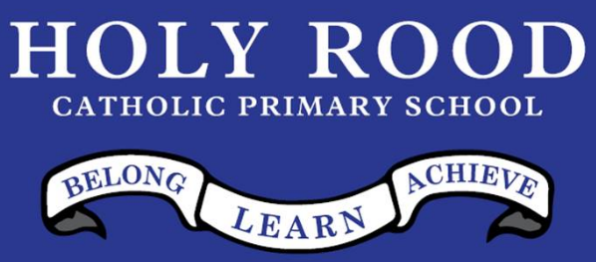

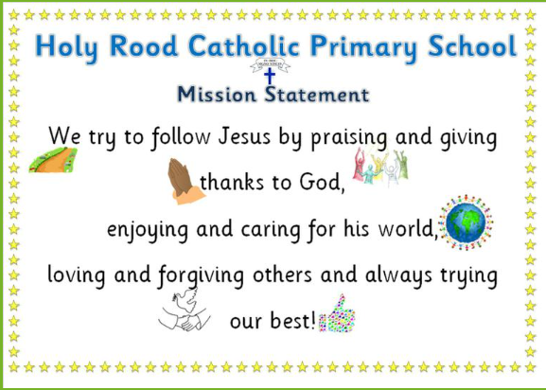

Our Science Vision
At Holy Rood Catholic Primary School, we understand how important science is in everyday life and we are committed to growing our children’s science capital. We want all pupils at Holy Rood to have the opportunity to be exposed to first-hand experiences that allow them to develop their scientific skills, knowledge and overall appreciation and understanding of the world around them.
To achieve this, we encourage and nurture our pupil’s natural excitement and curiosity through appropriate stimulus, exploration and questioning which is embedded in lessons with a focus on rich, well-modelled scientific vocabulary and concepts. We strongly believe that the quality of language that children are exposed to is fundamental to them developing their scientific vocabulary and articulating their scientific thoughts and findings in a clear and concise manner.
Within this environment, we believe that all children are capable of achieving their full potential within science. We teach to ensure pupil’s understanding is deep and secure allowing them to become inquisitive life-long learners, who can confidently question and investigate the world around them.

Curriculum Intent

Our Science programme offers opportunities for all children (regardless of barriers to learning) to:
- develop and secure scientific knowledge, vocabulary and conceptual understanding of biology, chemistry and physics.
- use different types of science enquiry that help them to answer scientific questions about the world around them in different ways and deepen their knowledge.
- be equipped with the scientific knowledge required to understand the uses and applications of science, today and for the future.
- use a range of cross curricular methods to communicate their scientific findings.
- use equipment carefully and accurately with a clear aim of their purpose.
- maintain enthusiasm and enjoyment of scientific learning and discovery.
- be curious about what is around them, ask questions and have opportunities to answer their own questions.
- raise scientific aspirations by applying knowledge from lessons to the real world, including highlighting different scientific careers.
- challenge stereotypes within science to ensure all children see themselves as scientists.

Curriculum Implementation
Teachers foster a positive attitude towards science learning within their classrooms and maintain an expectation that all children are capable of achieving within science.
Our whole school approach to the teaching and learning of science involves the following;
- Science will be planned and taught in accordance to the Science Progression Map with a clear idea of the scientific knowledge being taught and the ‘working scientifically skills’ children will develop throughout the unit. This approach is to ensure children are developing secure scientific knowledge to ensure that there is clear progression from one year group to the next.

- Children are given opportunities to conduct experiments: allowing them to problem solve and conduct further investigations based on their findings.

- Planning involves teachers creating engaging lessons, using high-quality resources, to support children in applying their knowledge to the world around them. Teachers will use precise questioning in class to test conceptual knowledge and skills, and assess children regularly to identify those children with gaps in learning, so that all children keep up.
- We build upon the learning and skill development of the previous years. As the children’s knowledge and understanding increases, and they become more proficient in selecting and using scientific equipment, collating and interpreting results, they become increasingly confident in their growing ability to draw conclusions based on real evidence.
- Working scientifically skills will be progressive throughout Key Stage 1 and Key Stage 2 and embedded into each lesson. Children, as they progress through Key Stage 2, will begin to develop the independence to compare and contrast different tools and their appropriateness, when presenting their findings.

- Key vocabulary and challenging concepts will be introduced through direct teaching; visible within the classroom; and regularly revisited to support all learners on their scientific journey.
Inclusion Statement

At Holy Rood, we believe all children are capable of achieving their full potential in science. Therefore, we teach with the aim for all children to be secure in their scientific knowledge and skills. This is achieved by using a range of strategies to support children’s barriers to learning, to give them the best possible opportunity to secure age-related disciplinary and substantive knowledge.
As 85% of our pupils speak English as a second language (as of February 2026), we ensure that vocabulary is explicitly taught, modelled and accompanied by visuals (where appropriate). Further to this, carefully chosen physical resources and high-quality videos are used to support children’s understanding of scientific concepts and application of scientific language.
Children are given opportunities to work collaboratively with supportive peers and tasks are adapted to support cognitive barriers to learning. Adaptations include, but are not limited to:
- word banks
- hands on experiences (trips where applicable and curriculum enhancement opportunities)
- sentence stems
- scaffolding of tables, graphs etc.
All learners are given a range of opportunities to revisit and recap prior learning through tile pages, purposeful working walls, lesson recaps and Memory Monday (KS1)/Quiz Booklets (KS2).
Curriculum overview
EYFS
In Early Years, the children are exposed to a continuous provision approach to understanding the world around them. Science makes a significant contribution to developing a child’s knowledge and understanding of the world. We begin to develop children’s understanding of the work by guiding children to make sense of their physical world and their community through opportunities to explore, observe and find out about people, places, technology and the environment.
Key Stage 1
The main focus of the teaching of science in key stage 1 is to enable pupils to experience and observe phenomena, looking more closely at the natural and constructed features of the world around them. It is paramount that children are encouraged to be curious and ask questions about what they notice. Building on the foundations of Early Years, children are supported to develop their understanding of scientific ideas by using different types of scientific enquiry to answer their own questions, through a ‘Look, Book, Test’ approach. They should begin to use simple scientific language to talk about what they have found out and communicate their ideas and findings in a variety of ways. Science learning will be predominantly through practical experiences with children taking the lead in conducting their own investigations and being supported to conduct research and use secondary sources, when appropriate. Pupils should read and spell scientific vocabulary at a level consistent with their phonic knowledge at key stage 1.
Lower Key Stage 2
Science teaching in lower key stage 2 should build on prior learning from key stage 1. Children will continue to grow their scientific knowledge, skills and vocabulary and increasing level of independence. They will do this through exploring, talking about, testing and developing ideas about everyday phenomena and the relationships between living things and familiar environments, and by beginning to develop their ideas about functions, relationships and interactions. They should ask their own questions about what they observe and make some decisions about which types of scientific enquiry are likely to be the best ways of answering them, including observing changes over time, pattern seeking, grouping and classifying things, carrying out simple comparative and fair tests and finding things out using secondary sources of information. They should draw simple conclusions and use some scientific language, first, to talk about and, later, to write about what they have found out. Pupils should read and spell scientific vocabulary correctly and with confidence, using their growing word reading and spelling knowledge.
Upper Key Stage 2
The principal focus of science teaching in upper key stage 2 is to enable pupils to develop a deeper understanding of a wide range of scientific ideas. At upper key stage 2, they should encounter more abstract ideas and begin to recognise how these ideas help them to understand and predict how the world operates. They should also begin to recognise that scientific ideas change and develop over time. They should select the most appropriate ways to answer science questions using different types of scientific enquiry, including observing changes over different periods of time, pattern seeking, grouping and classifying things, carrying out comparative and fair tests and finding things out using a wide range of secondary sources of information. Pupils should draw conclusions based on their data and observations, use evidence to justify their ideas, and use their scientific knowledge and understanding to explain their findings. Pupils should read, spell and pronounce scientific vocabulary correctly.
Science lessons
Typical lesson design
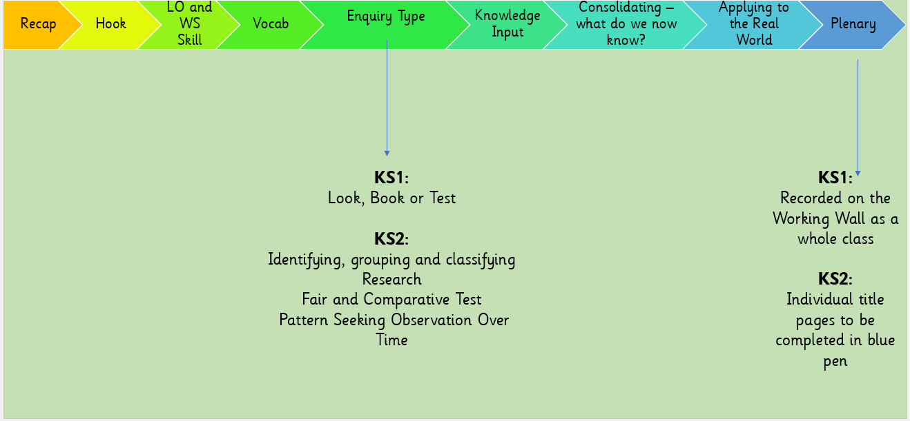
Planning and Marking

In line with the ‘Whole School Science Coverage Map’ (see Appendix 1), teachers will plan lessons to meet the objectives outlined in their year group’s ‘Yearly Overview’ (see Appendix 2). Outcomes in books should also reflect a range of working scientifically skills, in line with the ‘Whole School Working Scientifically Progression’ document(see Appendix 3).

Marking of children’s work should be timely and meaningful. Yellow highlighting should be used to demonstrate where children have met the learning objective. Green highlighting should be used to support addressing misconceptions and incorrect spelling of scientific vocabulary. Where necessary, a green pen question or sentence stem can be provided to support a child in addressing a misconception or to challenge a child’s scientific reasoning. With the support of the teacher, children should respond to marking using their blue pen to acknowledge feedback.

Presentation in books

At the start of each science unit, title pages are stuck in books/folders (see Appendix 4). In KS1, the title page has the key vocabulary for the unit and any visuals that may be useful for learners during the unit. In KS2, the title pages are broken into two key parts: the top half of the page is an opportunity to revisit prior learning that links to the topic about to be taught and the bottom half is where children add their new knowledge in blue pen throughout the unit.
At Holy Rood, there is an expectation that children will write in their Science books in pencil or pen (in years 5 and 6). The short date will be written at the top of the page and underlined before each new piece of work is completed. Under the short date, the learning objective (LO) and skill should be written and underlined by the children or provided on the task.

Assessment

At the end of each unit, children will complete an End of Unit Assessment so that teachers can assess how well they can apply their knowledge to different objectives. The results will then be entered into the tracking sheet to inform teacher assessment and next steps in teaching and learning.
At the end of the year, teachers will complete the working scientifically assessment at the top of the spreadsheet as an overall teacher judgement for the year.

Working Walls

All classrooms will have a science-working wall that reflects the unit that is currently being taught. Working walls should be treated as a progressive display, regularly being added to as children build their knowledge. Working walls should be a combination of visuals and the key vocabulary.
The five types of enquiry (KS1- look, book, test and KS2- observation over time, comparative or fair testing, research, identifying, grouping and classifying and pattern seeking) posters (see Appendix 5) will be displayed in every classroom and referred to during lessons.

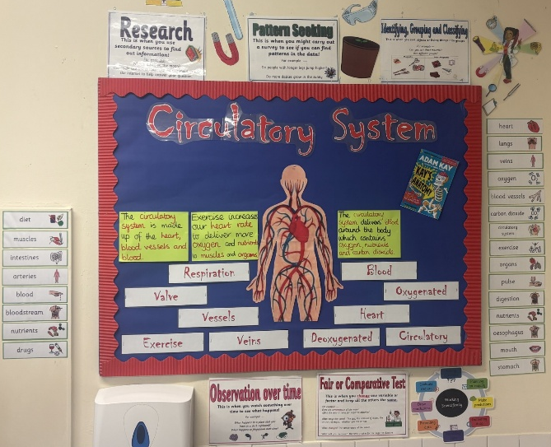
Every working wall should also have Professor Poric (see Appendix 6) on display and the Working Scientifically Wheel in KS2 only (see Appendix 7).

Health and Safety

Pupils will be taught to use scientific equipment safely when using it during practical activities. Class teachers and higher level teaching assistants should assess equipment before use, reporting and taking defective equipment out of action. Teachers will assess and mitigate risks associated with practical activities.

Curriculum Impact
At Holy Rood Catholic Primary School, we are working towards developing an inquisitive future generation who constantly question the world around them. We are achieving this by providing children with fun, well-resourced and engaging lessons as well as developing community links within Science to enrich children’s scientific experiences. We have worked to raise the children’s science capital so they can see how science affects all that is around them. We value pupil and staff voice by listening to the children’s and teacher’s opinions of science in our school and are always working with the children to find ways to improve this within our school. Through this all-encompassing approach, we are ensuring children are developing a greater-depth of knowledge that is secure and generative.

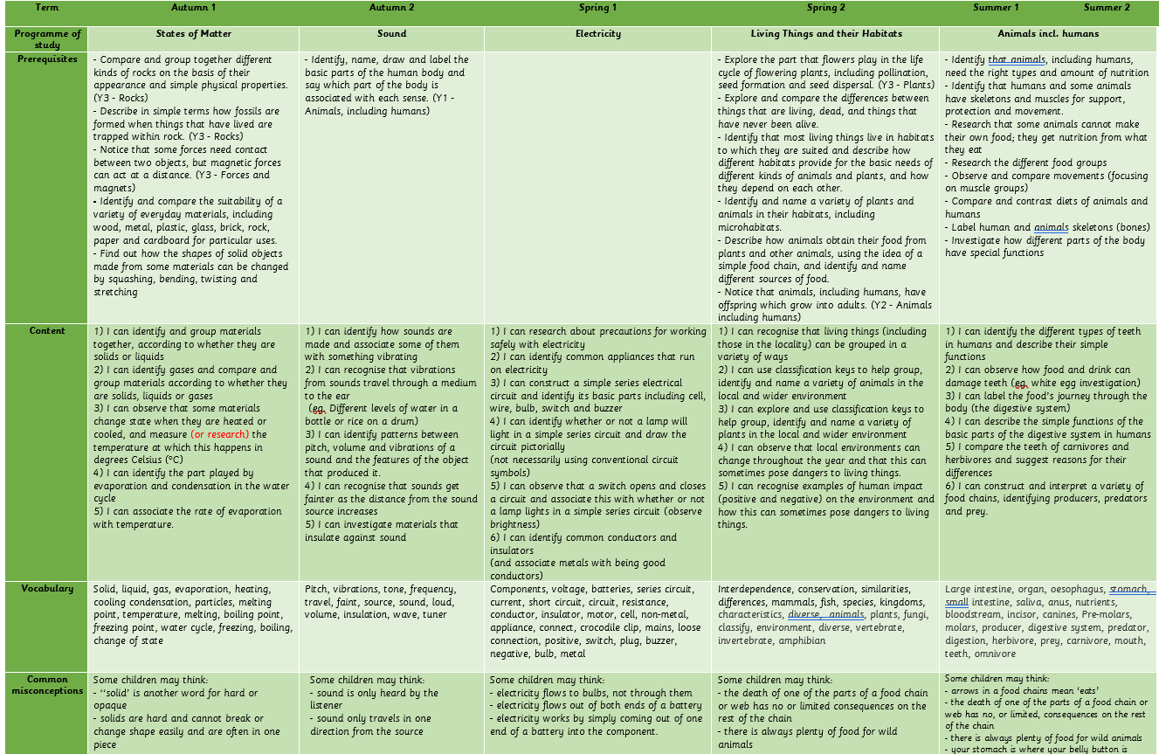
Appendix 1: Whole School Science Coverage Map
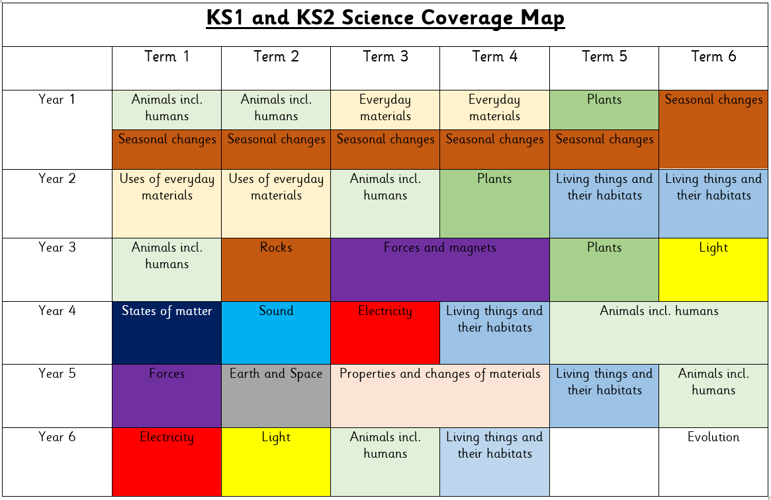
Appendix 2- Yearly overview (example)
Appendix 3: Whole School Working Scientifically Progression
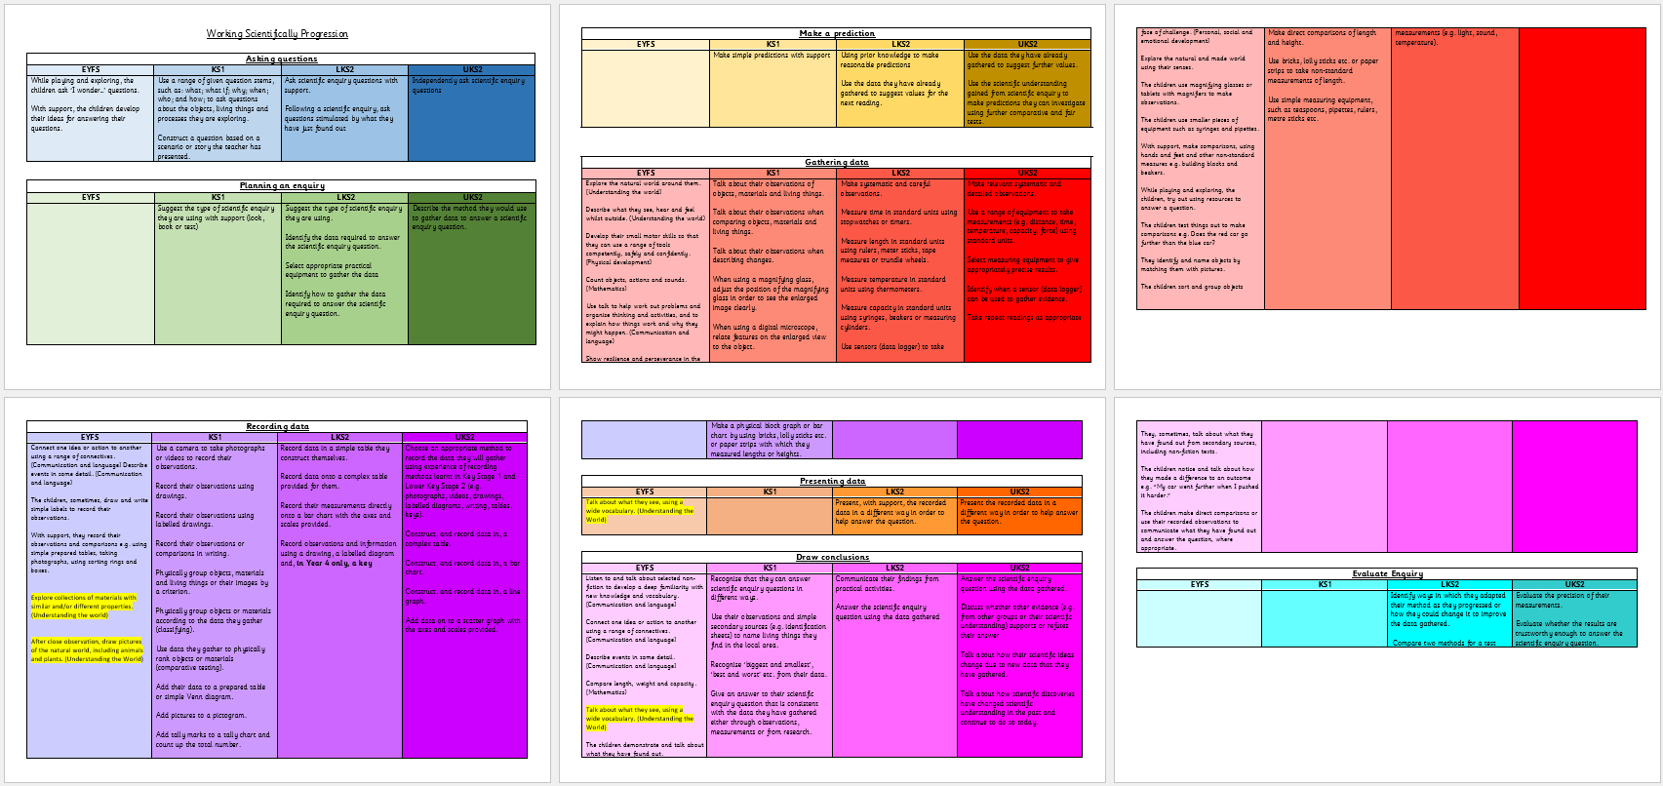
Appendix 4: Title Pages - examples
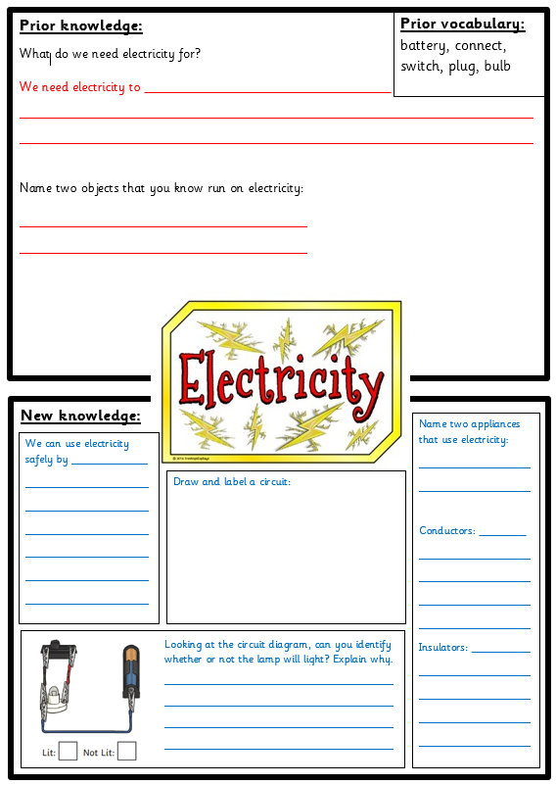
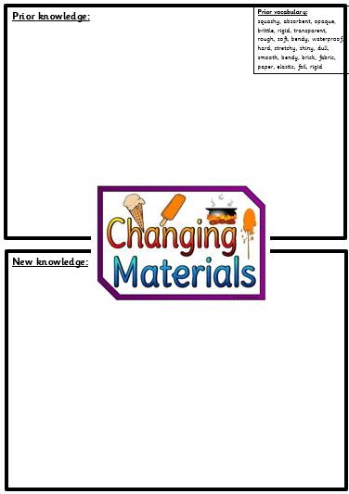
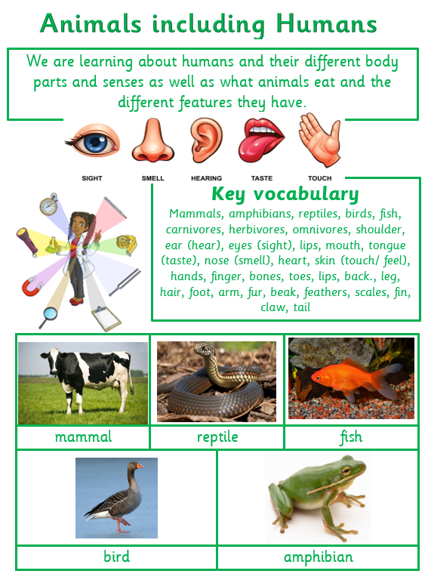

Key Stage 1 Lower Key Stage 2 Upper Key Stage 2

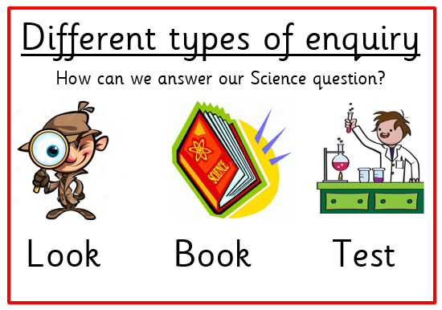
Appendix 5: Types of Enquiry
Key Stage 1

Key Stage 2
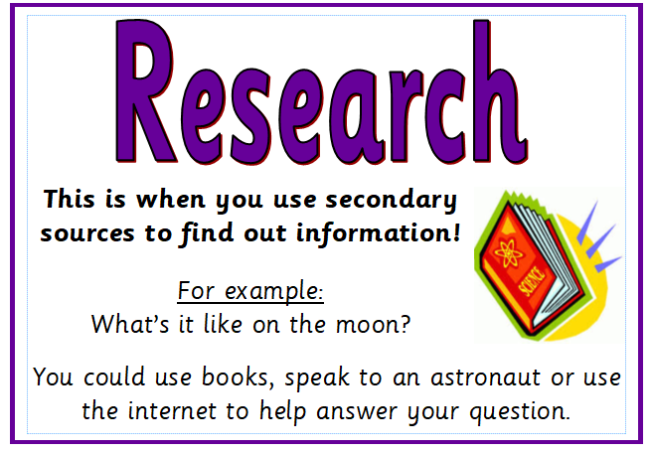
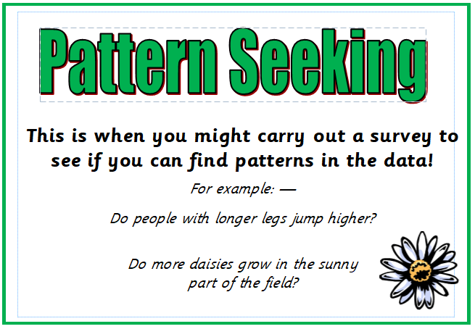
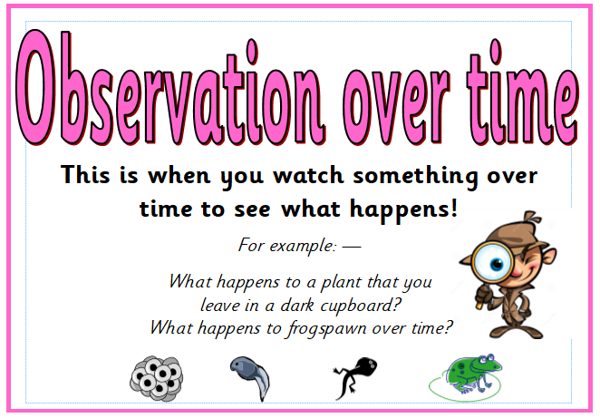
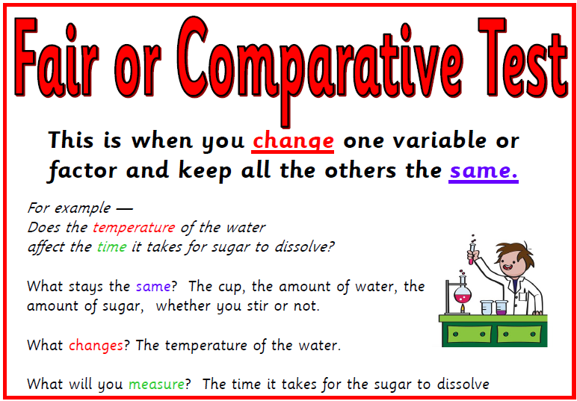
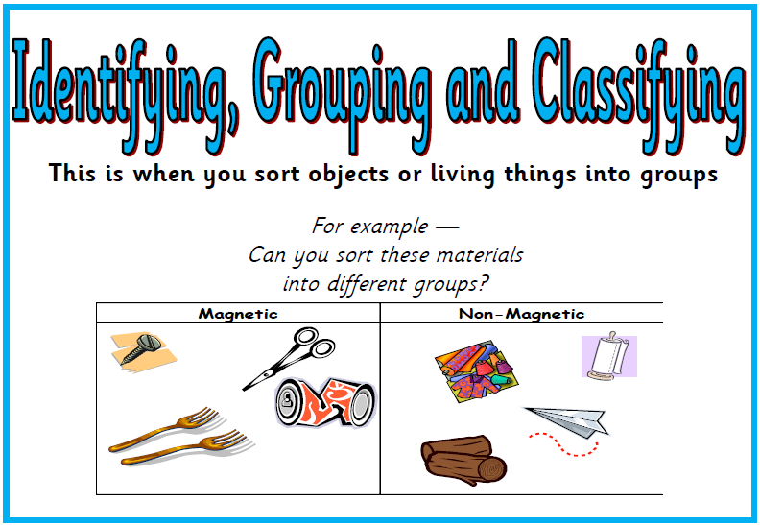

Appendix 6: Curriculum Crew character – Professor Poric
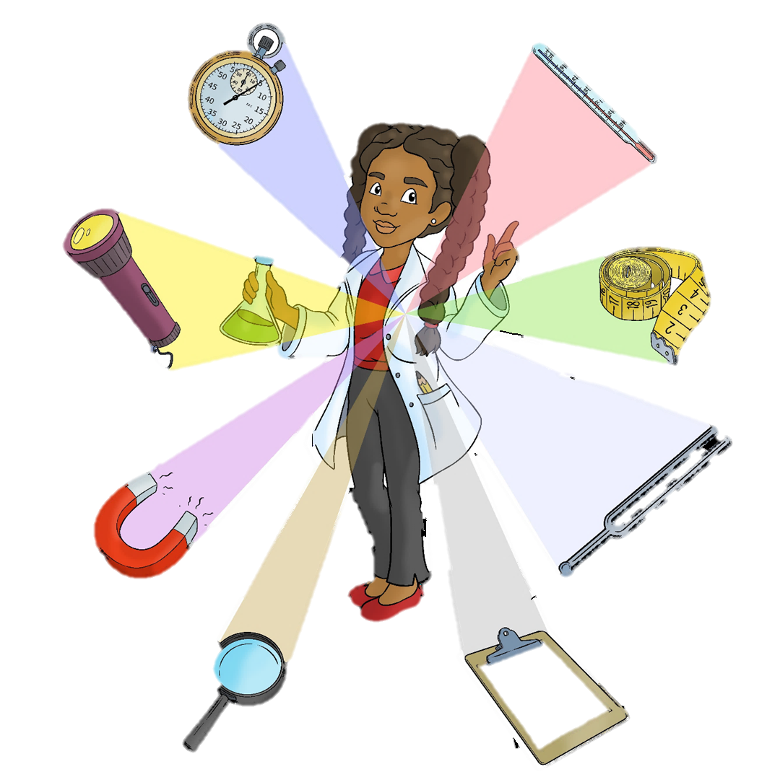
Appendix 7: Working Scientifically Wheel (KS2 only)


